Orators Report
on the 16th Degree
Prince of Jerusalem
Dec 5, 2012
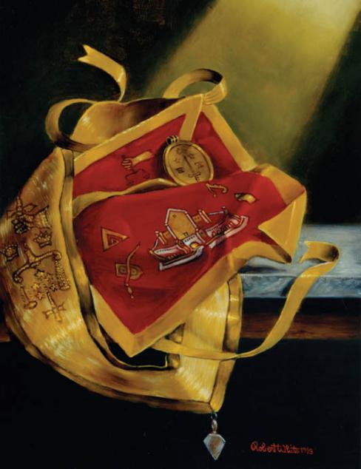

The apron is of crimson, lined and edged with the color saffron.
Bremerton Valley of the Scottish Rite
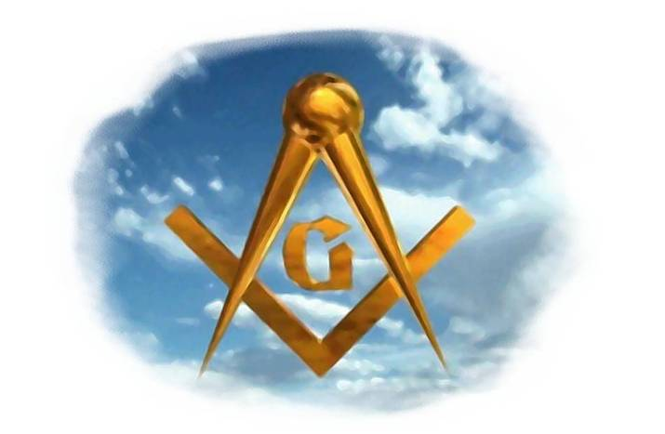

The Legend: The preceding degrees, until the 14th inclusive, deal with various aspects of the Hiramic legend, examining aspects such as duty, faithfulness, the knowledge and virtues that characterize a Mason.
The 15th and 16th degrees, serve as a transition between the Lodge of Perfection and the Rose-Croix Chapter. The legend is founded on certain incidents which took place during the rebuilding of the second Temple of Jerusalem. Shortly after obtaining permission of King Cyrus to reconstruct the edifice, and while the foundation was not yet complete, Cyrus died. Great apathy and indifference, in consequence, existed among the brethren, more especially as they were the subjects of hatred by the various tribes who constantly harassed them; and they were compelled to labor with the sword in one hand and the trowel in the other. The Jews were so much distressed by the attacks of the Samaritans and other neighboring nations and the resulting lawlessness and discord, that an emissary was sent to King Darius to implore his favor and protection, which was accordingly obtained. This legend has historical foundation based on the Book of Ezra. There is evidence that it was possibly derived by Baron de Tschoudy who composed the Degree of Knight of the East, and as that Degree is the first section of the system of which the Prince of Jerusalem is the second, it may be reasonably assumed that the latter was also composed by him. The Degree was introduced into America long before the establishment of the Supreme Council of the Ancient and Accepted Scottish Rite.
The Settings: The first apartment represents the Court of Zerubbabel, Governor of Judah, under the kings of Persia. The second apartment represents the council-chamber of Darius, the King of Persia.
The Ritual: In the First Apartment Joshua, the High Priest, succeeds in arousing a spirit of industry, and obtaining the consent of Zerubbabel to make application for protection and liberty to rebuild the Temple that had been delayed 17 years.
Zerubbabel and four princes set off to Babylon. On the way they are set upon by ruffians requesting payment for passage. They engage in conflict, and the enemy is repulsed.
In the Second Apartment, they reach Babylon and the council-chamber of the King of Persia. Zerubbabel and the four princes request the King to support the edicts under royal authority of King Cyrus that allow them to rebuild the city and Temple.
Darius gives orders that a search should be made for the edict of Cyrus. It is found containing all that the Jews had claimed. Darius, therefore, makes a new proclamation insisting that no obstacle should be put in the way of the people of Jerusalem, that the building of the Temple should be forwarded, that interference with the work should be a capital offense and that contributions should be made in money and goods from the kings local revenues for the expenses of the restoration.
Zerubbabel and four princes return to Jerusalem. Where they proclaim that King Darius has confirmed the decree of Cyrus and ordered the rebuilding of the city and House of the Lord. Zerubbabel further establishes a tribunal of princes to reestablish justice, peace, and equity for the people who have been subject to turmoil for many years.
At this point, the candidate is made a Prince of Jerusalem and is reminded to give hope to the persecuted and oppressed balanced by impartial justice. Zerubbabel creates a Prince, which honor is confirmed by the Jews, and made a Masonic grade of distinction.
The Lecture: A Prince of Jerusalem is no longer expected to rebuild the Temple at Jerusalem. In Morals and Dogma, Pike asserts "the whole world is God's Temple, as is every upright heart:' 'The pursuit of Masonry is to build the Symbolic Temple all over the world. The special tools of a Prince of Jerusalem are justice and equity; but we are not to forget those tools which we have learned in previous degrees. To follow the path of Masonic Truth is to understand that the action of life is the arena for spiritual and moral improvement because all of life and the world is spiritual and moral.

THE MORAL TEACHING This degree emphasizes the fact that one must use every means to be beneficial for the society in which one lives. We not only set our own example for our society, but we enlist the aid of our Brothers. Together, Masons are custodians of freedom. Our charge is to leave a noble heritage to those who follow us in this world. We build temples of the Living God in our hearts by following the truths of justice, equity, morality, wisdom, labor, fidelity and Brotherhood - so that the collective liberties for mankind can be protected.
DUTIES: To direct and aid those who labor to build the Symbolic Temple. Judge equitably and fairly. Provide aid of whatever kind to fellow Princes of Jerusalem. Keep faith in the justice and beneficence of God. Press forward with hope for the persecuted and oppressed.
FOR REFLECTION: Will you leave a noble heritage to those who follow you in this world?
IMPORTANT SYMBOLS: The color saffron, the Seal of Solomon, the colors white, blue, red and violet, five steps to the throne, the scales or balance.
The apron is of crimson, lined and edged with the color saffron. On the flap is an equal balance, held by a hand of justice. In the middle of the apron is a representation of the Second Temple, on one side of which is a sword lying across a buckler, and on the other, a square and a triangle. On the left and right sides are the Phoenician letters equivalent to the Greek letters Alpha and Theta. The colors, crimson bordered with that of the dawn (saffron), are symbolic of faith in the justice and beneficence of God, and of the dawn of hope for the persecuted, proscribed and oppressed. The equal balance, held by the hand of justice, is a symbol of righteousness and impartiality in judgment and of that equilibrium which the Deity maintains throughout the universe.

Adapted from the Spanish version of Rex R. Hutchen’s book A Bridge to Light

